Skyline Audit Logging

# Introduction

This tutorial covers how to use the Skyline audit log. The audit logging system keeps track of all document modifications and displays them in an interactive grid, similar to the Document Grid. It benefits from all the features of the Document Grid, such as creating report templates, sorting by columns and editing cells, for example for adding a Reason to a log entry. One of the design goals of the audit log was to give anyone the ability to reconstruct the state of a document, given only the audit log and the original data. This makes it an invaluable tool for a researcher using Skyline. As you will see, the audit log also makes the “Undo-Redo” feature more usable by providing more specific change messages and allowing you to undo changes in the audit log grid itself. To demonstrate important benefits of the audit log, this tutorial is based on the Absolute Quantification Tutorial, in which the absolute abundance of a target peptide is determined using Selected Reaction Monitoring (SRM) mass spectrometry by creating an external calibration curve with an internal standard heavy labeled reference peptide. This tutorial will be mostly focused on how to configure the audit log, how your actions are logged and how to read and work with the audit log. If you find you want to learn more about absolute quantification, you should refer to the Absolute Quantification Tutorial directly, which covers the topic in more detail.

# Getting Started

To start this tutorial, download the following ZIP file:

<https://skyline.ms/tutorials/AuditLog.zip>

Extract the files in it to a folder on your computer, like:

C:\Users\tobiasr\Documents

This will create a new folder:

C:\Users\tobiasr\Documents\AuditLog

The folder should contain a total of 9 RAW files, which you will import into Skyline later.

**Note:** In configuring Skyline for this tutorial, be sure to follow the steps below in the order presented to avoid creating audit logs of these initial setup steps.

* Start Skyline.
* If you are using Skyline for the first time you will be prompted to select a default user interface. In the right-hand corner, ensure that the protein icon  is showing, indicating that Skyline is presenting the **Proteomics interface**. This can easily be changed in the future.
* On the **Start Page,** click **Blank Document** which looks like this:

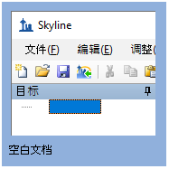

* On the **Settings** menu, click **Default.**
* Click **No** on the form asking if you want to save the current settings.

The document settings in this instance of Skyline have now been reset to the default, but you may still have an audit log entry describing what it took to get from any previous settings back to the defaults.

* On the **File** menu, click **New**.
* When prompted whether you want to save your changes, click the **No** button.

## Opening the audit log

Now open the audit log by doing the following:

* On the **View** menu, choose **Other Grids** and click **Audit Log** (Alt + 4)

This should bring up the **Audit Log** view in its default configuration as shown below:

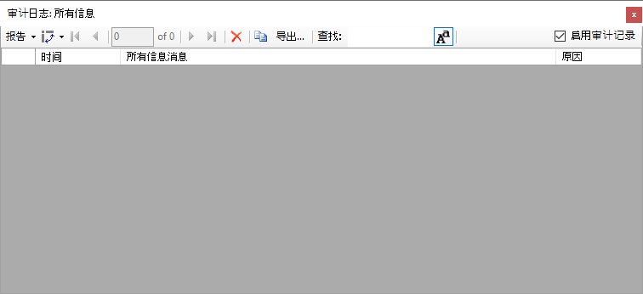

In the top right corner, you can see that audit logging is currently enabled, which is the default. By unchecking the box, audit logging can be disabled. Initially the audit log is showing its default column configuration, displaying the **Time**, **All Info Message**, and **Reason** columns. These columns will be explained in more detail and you will learn how to customize the columns in this grid. Keep this window open throughout the tutorial to observe how log messages appear as you interact with Skyline.

# Configuring Settings for Inserting a New Peptide

Before you insert a new peptide into the document, you need to configure the transition and peptide settings for this experiment as follows:

* On the **Settings** menu, click **Transition Settings**.
* Click the **Filter** tab.
* In the **Product ion selection** box, in the **From** dropdown list select **ion 3** and in the **To** dropdown list‘**last ion – 1**’.
* Click the **OK** button.

After you click **OK**, several messages will appear in the audit log window. Before taking a closer look at the audit log, first configure the peptide settings as follows:

* On the **Settings** menu, click **Peptide Settings**.
* Click the **Modifications** tab.
* Click the **Edit list** button next to the **Isotope modifications** list.
* Click the **Add** button.
* From the **Name** dropdown list choose ‘Label:13C(6)15N(2) (C-term K)’.
* Click the **OK** button.
* Click the **OK** button in the **Edit Isotope Modifications** form.
* In the **Isotope modifications** list, check the new ‘Label:13C(6)15N(2) (C-term K)’ modification.
* Click the **OK** button in the **Peptide Settings** form.

# Reading the Audit Log

Now the **Audit Log** view should look like this:

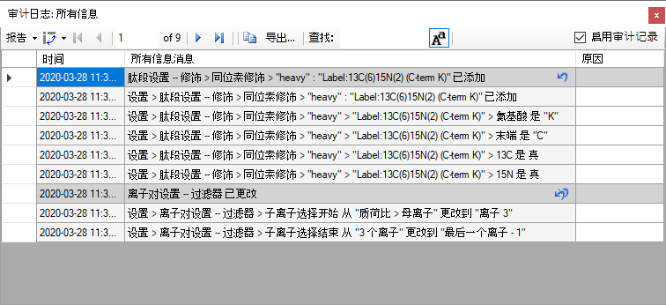

Each dark gray message and all messages below it until the next dark gray message or the end of the audit log represent a single undoable operation. The transition settings and the peptide settings were changed, which creates a total of two audit log entries. By default, new messages appear at the top like an email inbox. Looking at the first entry when the transition settings were changed, the gray message is a one line summary of the entire entry: **Transition Settings – Filter changed**. This message is called the **Undo-Redo message**, because it is also used in the Skyline Undo and Redo dropdown lists. To see this, return to the main Skyline window where you can:

* In the main toolbar, click the small black dropdown arrowhead next to the **Undo** button.

You will see a list of the changes you have made to the Skyline document like this:

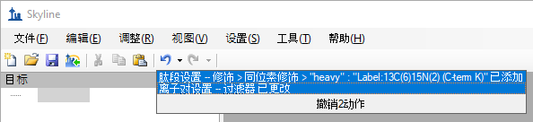

Before audit logging was introduced into Skyline, both messages here would have only said **Changed settings**. Therefore, even if you have audit logging disabled, you can still benefit from it through improved Undo and Redo descriptions.

Return to the **Audit Log** view. The next five messages under the **Undo-Redo message** are the **All Info messages**, which describe every change in detail. Log messages will tell you exactly where a setting changed. For instance, the first message reads **Settings > Transition Settings – Filter > Product ion selection start changed from “m/z > precursor” to “ion 3”**. Recall that this is exactly where we navigated earlier to select the collision energy. The “greater than” symbols indicate that a menu item, while the “--" indicates that what follows is a tab, such as the **Filter** tab. Next look at the message above, which describes the changes you made to the peptide settings. Note that the **Undo-Redo message** is a concise description of the isotope modification you added. Looking below at the **All Info messages**, you can see that the audit log contains the exact definition of the modification you added, despite you not having configured it manually. This is to allow others to reproduce those changes in the future, even if they do not have this particular modification in their Skyline instance, in which case they would have to create it manually.

# Undoing Changes Using the Audit Log View

Again, looking at the **Audit Log** view, you should see that there is a single leftward curving arrow next to the audit log entry at the top that describes the peptides settings changes. This is the same arrow as on the **Undo** button in the toolbar.

* Click the arrow in the top row of the **Audit Log** grid.

This should make the audit log entry disappear and undo the change.

In the main Skyline toolbar and you should see the **Redo** button that was previously a grey arrow pointing rightward, turn blue. To see the dropdown list of changes you can redo:

* Click on the small black arrowhead to the right the **Redo** button in the main toolbar.

You will see the list shown below.

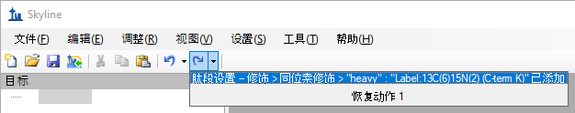

You can see the change you just undid through the **Audit Log** grid.

* Click on the change to redo the operation.

Now return to the **Audit Log** grid and you will see that the audit log entry is back. Note that next to the other audit log entry below it is an icon with two undo arrows. This indicates that if you undo this change, all changes made after this one will also be undone. In this case undoing the transition settings change entry will also undo the peptide settings change entry. This exactly how undo works when using the undo dropdown list in the toolbar. You can undo back to a certain point in the document history, but you cannot revert a single change in the middle of the list. Note that once you close Skyline and open the document, those undo arrows will disappear from the audit log, since only changes made during your current Skyline session can be undone or redone, again consistent with the **Undo** and **Redo** buttons and menu items.

# Inserting a Peptide Sequence

To add a peptide target to your new document perform the following steps:

* On the **Edit** menu, choose **Insert** and click **Peptides**.
* Copy “IEAIPQIDK”to the clipboard and paste it into the first **Peptide Sequence** cell.
* Copy “GST-tag”to the clipboard and paste it into the first **Protein Name** cell.

The form should now look like this:

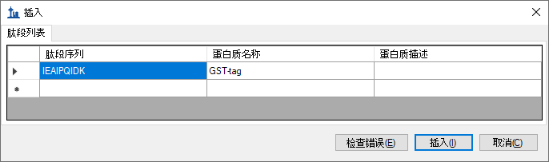

* Click the **Insert** button.

The **Targets** view should show the newly added peptide with a light and a heavy labeled precursor:

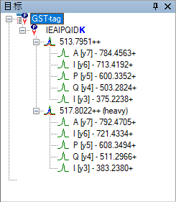

If you do not see all of the elements shown above, do the following:

* On the **Edit** menu, choose **Expand All** and click **Precursors**.

Refer to the **Audit Log** grid and you should see a new message as the first row indicating that you inserted the peptide IEAIPQIDK. There are no other detailed messages about this change. The audit log entry consists of a single audit log messages as shown below:

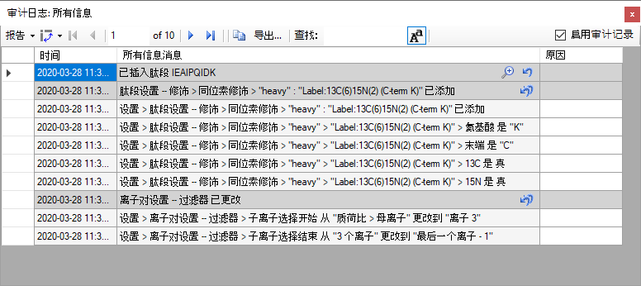

Note that there is a magnifying glass icon next to the new audit log entry. This appears whenever there is extra information associated with an audit log entry.

* Click on the magnifying glass.

This will bring the **Audit Log Extra Information** form as shown below:

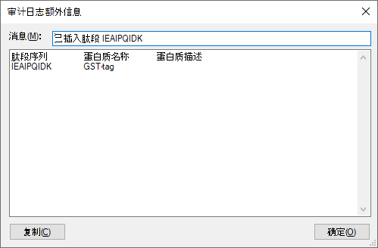

The extra information window shows all the information that was pasted into the grid when inserting the peptide, including the column header names. The cell values are separated by tab characters, which means you can copy entire rows from this window and paste them into the **Insert Peptides** form you just used to reproduce this operation.

* Click the **OK** button to close the **Audit Log Extra Information** form.

Before continuing, you should save the document.

* On the **File** menu in Skyline, click **Save As**.
* Navigate to the AuditLog folder created earlier.
* In the File name field, enter “AuditLogTutorial”.
* Click the **Save** button.
* On the **File** menu, click **Open containing folder**.

In the Windows File Explorer, you should see a file called“AuditLogTutorial.skyl” (along with AuditLogTutorial.sky and .sky.view). If you do not see these file extensions, you may need to show file extensions in the File Explorer. This .skyl file is the audit log file. If you open it in a text editor like Notepad, you will see XML format text. If you are interested in the format, refer to the audit logging paper (in review at *Bioinformatics*). The audit logging file (like the .sky.view which contains window layout and selection information) can be deleted at any time without damaging the document stored in the .sky file.

# Importing Data Files into Skyline

Your next task is to import the mass spectrometer data files from the SRM runs for this experiment:

* On the **File** menu, choose **Import** and click **Results**.
* Use the **Add single-injection replicates in files** option in the **Import Results** form. (default)
* Click the **OK** button.
* In the **Import Results Files** form, navigate to the AuditLog folder and select all of the 9 raw files.
* Click the **Open** button to choose the files.

After the import completes, Skyline should have created 9 new replicates. The **Audit Log** view should now look like this:

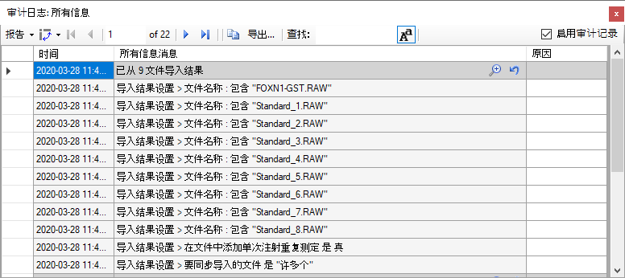

The audit log did not create copies of the files that were imported, but rather just stored the paths of files (here shortened to just the file names). The first 9 detailed messages are the paths of the 9 raw data files you imported. The last two messages describe the settings in the **Import Results** form when you clicked the **OK** button.

Note that the primary entry again has a magnifying glass around a plus sign, which means it has extra information associated with it. This is always the case for a series of dialogs such as when importing results, where you configure a process that modified the document, instead of directly modifying the document like when changing the settings.

* Click on the magnifying glass to view the extra information.

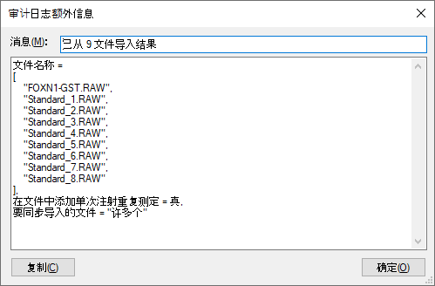

* Click the **OK** buttonto close the form.

The extra information for wizards like the import results wizard does not contain any additional information, but rather a neatly formatted and more concise version of what is in the audit log. If you have any programming experience, this format might look familiar to you.

# Calibration Curve Settings

Now, configure quantification settings to help Skyline calculate a calibration curve:

* On the **Settings** menu, click **Peptide Settings**.
* Click the **Quantification** tab.
* In the **Regression Fit** dropdown list, choose “Linear”.
* In the **Normalization Method** dropdown list, choose “Ratio to Heavy”.
* In the **Units** field, enter “fmol/ul”.
* Click the **OK** button.

This adds the audit log entry shown below:

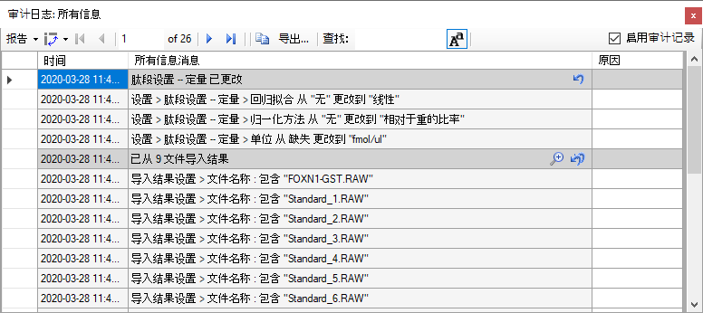

The changes made are listed under the heading **Peptide Settings – Quantification changed** and each step is captured in a detailed message describing it with enough detail that the step could be repeated.

## Specify the analyte concentrations of the external standards:

Next, specify the analyte concentration for each replicate using the **Document Grid** as follows:

* On the **View** menu, click **Document Grid**.
* In the top left of the **Document Grid**, click the **Reports** dropdown list and choose **Replicates**.
* In the row for FOXN1-GST, set its **Sample Type** to “Unknown”.
* Copy the following data and paste it into the **Document Grid** to set each of the “Standard_#” replicates **Sample Type** to “Standard” and their **Analyte Concentrations** to the values below.

|  |  |
| --- | --- |
| 标准 | 40 |
| 标准 | 12.5 |
| 标准 | 5 |
| 标准 | 2.5 |
| 标准 | 1 |
| 标准 | 0.5 |
| 标准 | 0.25 |
| 标准 | 0.1 |

The **Document Grid: Replicates** form should look like this:

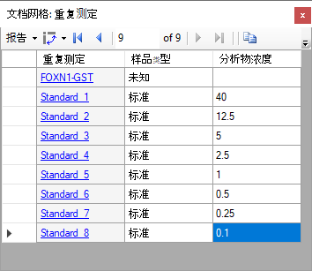

Review the **Audit Log** grid to see that it shows the following:

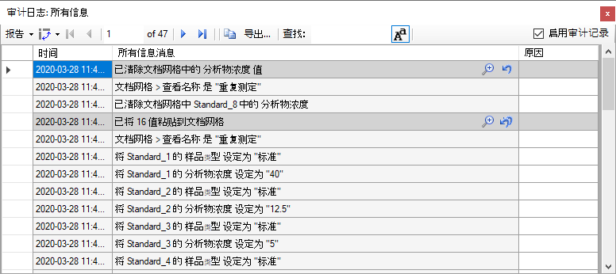

The Undo-Redo messages indicates that 16 values were pasted into the **Document Grid**. There are a total of 17 detailed messages. The first message indicates that the **Replicates** report was used. This is important because in order to reproduce this change made in the **Document Grid**, you need to know what columns were present. The follow 16 messages describe each cell change, one for each of 8 changes in the **Sample Type** column and 8 in the **Analyte Concentration** column. Since you pasted data, this audit log entry again contains extra information.

* Open the extra information window by clicking on the magnifying glass icon.

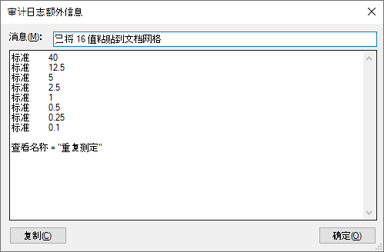

This displays a much more concise view of the data that was pasted into the document and again the data can be easily copied and pasted to reproduce the operation. The report that was used is also indicated at the end of this extra information – in this case: **“Replicates”.**

* Click the **OK** buttonto close the **Audit Log Extra Information** form.

# Adjusting Integration Boundaries

Next, you will look at the integration boundaries of the peptide in the FOXN1-GST sample:

* On the **View** menu, choose **Arrange** **Graphs** and click **Tabbed**.
* Click on the **FOXN1-GST** tab, or select the **FOXN1-GST** replicate in the dropdown list labeled **Replicates** at the top of the **Targets** view.
* Ensure that the IEAIPQIDK peptide is selected in the **Targets** view.

Now you should see the chromatograms of the IEAIPQIDK peptidein the FOXN1-GST sample.

By selecting either the light or heavy precursor in the **Targets** view you can review the integration boundaries for that precursor.

* Select the heavy precursor and zoom in on the peak using the scroll-wheel beneath the x-axis.

You should see something like the following:

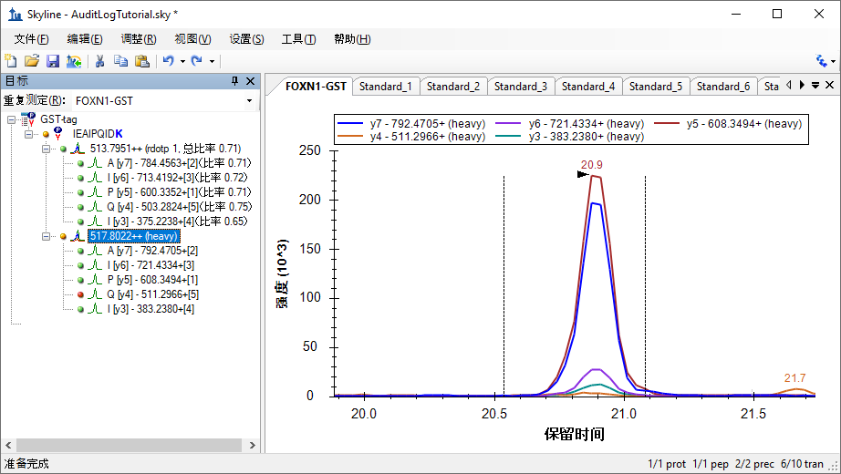

The integration boundaries look acceptable and changing them may simply add variance to the peak area calculations. However, you might feel the peak could be better centered within the integration range. To make a change like this, do the following:

* Click beneath the x-axis where you want the range to start and hold while dragging until the cursor is under where you want the range to end. (e.g. 20.65 to 20.15)

Three new rows should appear in the **Audit Log** view, as shown below:

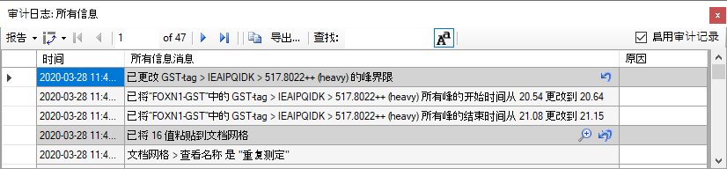

Note that the new log entry describes a change related to an item in the **Targets** window, it uses a format similar to the one seen previously when changing document settings. Generally, the audit log will refer to items in the **Targets** view by **Protein/Peptide List > Peptide > Transition group > Transition**.

When someone else reads this audit log, this integration boundary change might seem arbitrary without any explanation. Or, months or years later, you may have forgotten why you made this change. To document your reasoning do the following:

* Click in the **Reason** cell next to the log message.
* Enter a Reason such as “*Changed peak integration as instructed by the tutorial*” and press Enter.

The audit log should look like this:

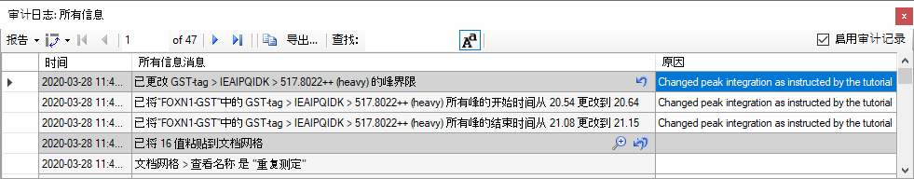

Note that the reason entered in the dark gray row is shown in all three new rows. This is the overall reason for the change. To give a different reason for each row, you would need to use a report field called **Detailed Reason**. You will learn how to customize the columns shown in the **Audit Log** view below.

# Calibration Curve Review

Now view the calibration curve you have configured as follows:

* On the **View** menu, click **Calibration Curve**.

The curve fits the first four points, but not as well for the points closer to zero. Use the scroll wheel to zoom in on the lower four points.

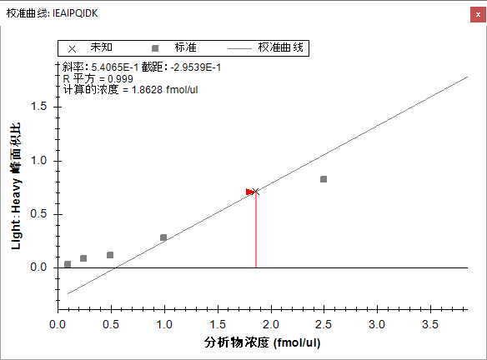

You can see that the last three points fall off the line, which indicates that they are below the limit of detection for this peptide. These three and the fourth lowest concentration point may also be pulling the regression line away from the fourth highest concentration point at 2.5 fmol/ul. To create a better fit for the four highest concentration points, you can exclude the four lower points from the regression as follows:

* For each of the lowest four points, right-click on the point and click **Exclude Standard**.

If you zoom out on the other four points, you should see that the curve fits them better now, and the R-Squared value in the top left corner of the graph should become 1.

Review the **Audit Log** grid and, you should see four new entries, one for each point you excluded from the calibration:

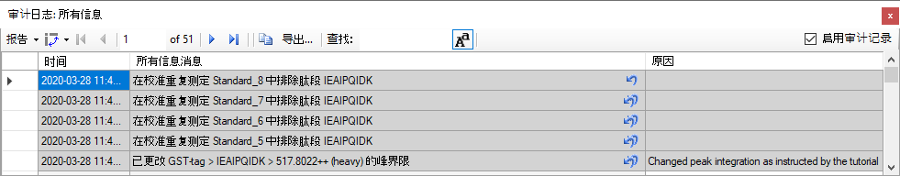

You should again add a reason to explain why the replicates were excluded by doing the following:

* Click on the top **Reason** cell and enter “*Excluded standard below LOD*” and press Enter.
* Select all four **Reason** cells.
* Right-click on the selection, and click **Fill Down**.

# Customizing the Audit Log Display

You now have a growing audit log and it has become difficult to see all your changes at once. The **Audit Log** view is based on the **Document Grid** and can, therefore, be customized just like the **Document Grid**:

* In the top left corner of the **Audit Log,** click on the **Reports** menu.

There are three default reports you can choose from (**Undo Redo**, **Summary**, and **All Info**):

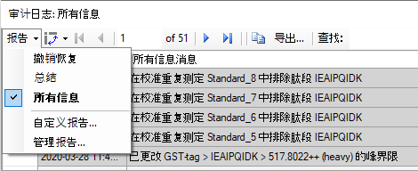

* Click on the **Undo Redo** menu item.
* Adjust the column widths so you can see their full contents.

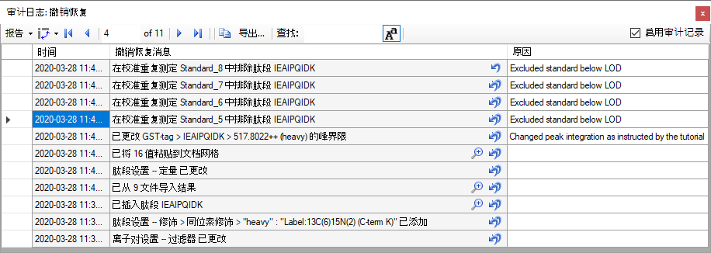

Now the **Audit Log** view only displays the **Undo Redo** messages and not the detail messages, presenting a concise overview of what you changed in the document. Going from bottom to top, your changes can be summarized as follows:

* You first configured the transition settings and peptide settings to include the desired transitions and modifications.
* You inserted the peptide.
* You imported the results.
* You started configuring the calibration curve, by configuring quantification settings.
* You pasted the standard and analyte concentration information into the document grid.
* You adjusted one of the peak boundaries and provided a reason for it.
* Finally, you excluded four standards from the calibration curve, again providing a reason.

Next, you will customize the **Audit Log** view manually to show other columns:

* In the top left corner of the **Audit Log** view, click **Reports** and choose **Customize Report**.
* Check the **Skyline Version** and **User** columns in the left-hand list.
* In the **Report Name** field, enter ‘Custom Columns’.

The filled-out form should look like the following:

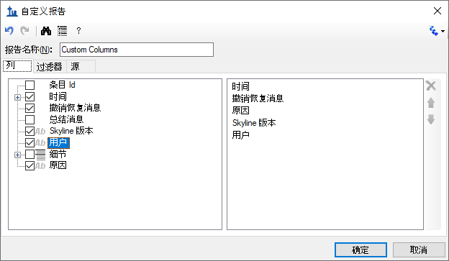

* Click the **OK** button.

The **Audit Log** should now look like the following, although you will have a different **User** name and you might be using a different **Skyline Version**.

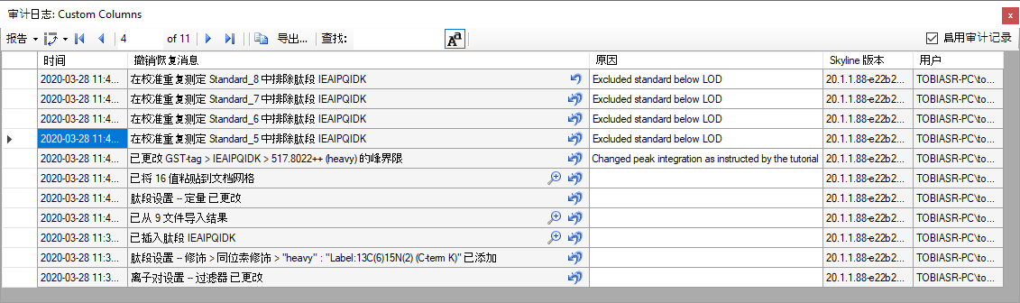

Below is a list of all of the columns you can display and their meaning:

* **Time Stamp:** Time at which the change was made (adjusted to your local time).
* **Undo Redo Message:** The most specific single line message describing the entire document change. This message will also be displayed in Skyline’s toolbar when clicking on the arrows next to the Undo-Redo arrows.
* **Summary Message:** Similar (and often the same) as the Undo Redo Message, but for certain messages shorter.
* **All Info Message(s):** A list of messages that describe the document change in detail.
* **User:** Identity of the user who made the change as authenticated by the local operating system.
* **Reason:** The reason for the change, which can be set by editing the cell in the audit log grid after the change was made. (Optional)
* **Detailed Reason:** A reason that can be set for each of the detailed “All Info messages”. (Optional)
* **Extra Info:** additional information, usually large amount of data pasted into the document. (Optional)

# Panorama Upload

To proceed with the rest of the tutorial you need an account established on PanoramaWeb.org or another web server running Panorama.

Panorama is a web-based proteomics data sharing platform that supports uploading and viewing of Skyline files. To upload your Skyline document into Panorama:

* On the **File** menu, click **Upload to Panorama**.

If you have not used Panorama before the following message should appear:

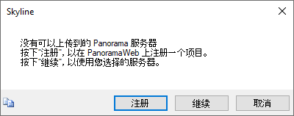

* Click the **Continue** button.

The next form should ask you for the URL of the Panorama server you want to use and your credentials.

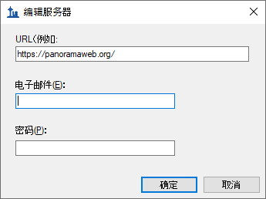

* Enter the URL if you are using your own Panorama server, or leave it as PanoramaWeb.org.
* In the **Email** and **Password** fields, enter your credentials.
* Click the **OK** button.

If the connection was successful, the next form should show you the Panorama server URL and the folders on the server available for upload.

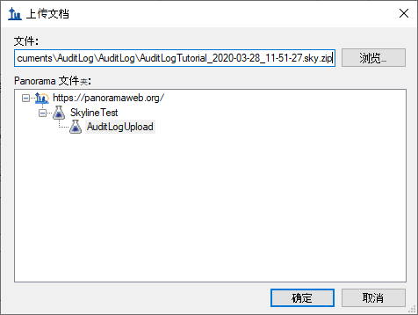

* Click the **+** next to the URL to expand the list of folders you have access to if necessary.
* Select the folder into which you want to upload the document.
* Click the **OK** button.
* Click the **Yes** button in the next form to open a web browser to uploaded document.

Skyline automatically creates a ZIP file containing all the files associated with your document and uploads it to the Panorama server. Click OK when asked to open the document in Panorama. You might be asked to log in to Panorama in the browser first. Once you have signed in the page should look like this:

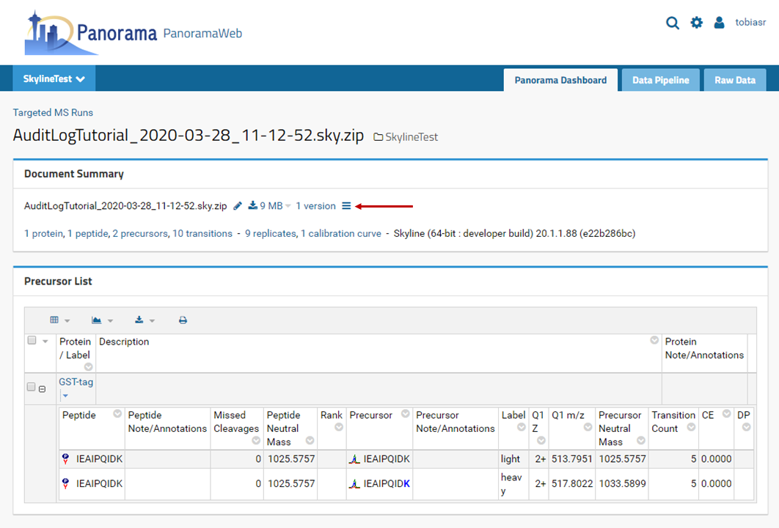

|  |
| --- |
| Detailed discussion of the Panorama functionality is beyond the scope of this tutorial. Please refer to <https://panoramaweb.org/sharing_documents.url> for more details. |

Note the ≡ symbol next to the number of document versions. This is a link that allows you to access the audit log information for the document. If you upload a document without a valid audit log this symbol will not be shown.

* Hover mouse cursor over the ≡ symbol to observe the explanatory tooltip.
* Click the ≡ symbol.

Now you should see the following page:

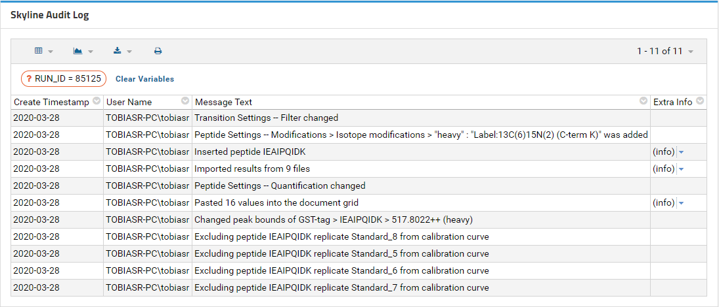

This is an audit log viewer very similar to the Audit Log grid in Skyline. For the sake of brevity, it shows Undo Redo messages only by default, but full details are available through the grid button on the left. It is very similar to the Skyline **Reports** menu and allows you to select, create, and customize grid views. By default, Panorama ships with the **default** view and **AllMessagesView**, but you can also create your own.

* Click on the **Grid View** button
* Select **AllMessagesView** from the dropdown menu.

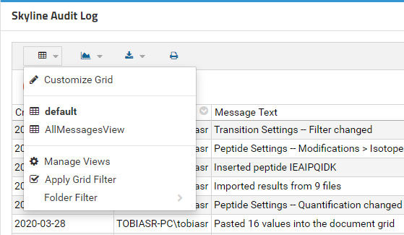

Now your page should look like this:

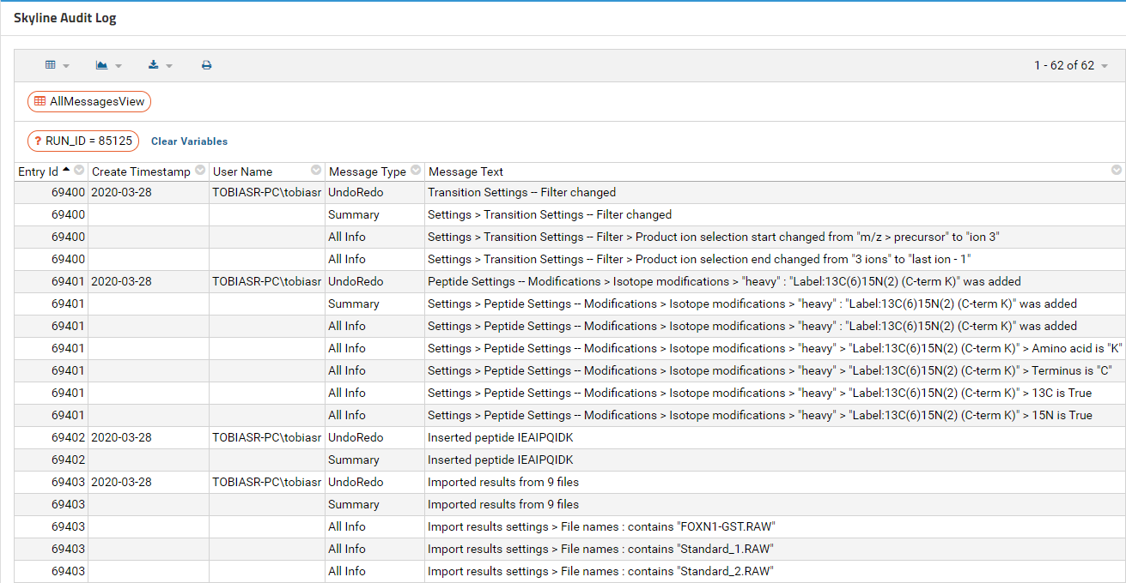

All the messages and message types in the audit log are now displayed.

# Conclusion

This tutorial went through setting up an absolute quantification experiment to demonstrate how to use the Skyline audit log and how to upload it to Panorama. The audit log keeps tracks of all changes you make to your document and is fully customizable. It is a powerful tool to reproduce the state of a document from scratch and can be useful when working on the same document with collaborators or when requesting troubleshooting help from the Skyline team.